**BUG REPORT : 1**

**Date**: 03-07-2024

**Reported by**: Mirza MD Tawhid

**Summary:** Sign in Username(email address) Issue

**Descripton:**

When we give input on username email address field it takes only number such as [11111@gmail.com](mailto:11111@gmail.com). That should not be valid.

**Steps to reproduce**:

* Go to application
* Go to Sign in
* input : email Address field = anynumber@gmail.com
* The validation option shows valid

**Expected Result:**

* system should display an error messege

**Actual Result**: It shows valid

**Attachments:**

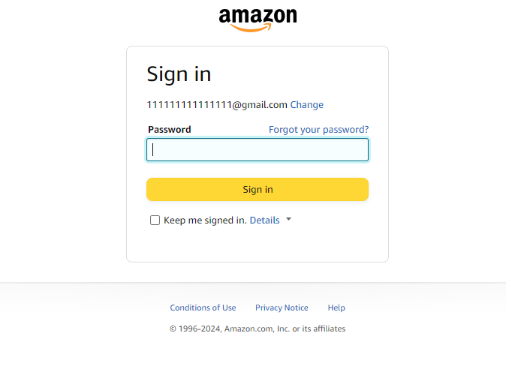

**Environment:**

* Operating system: Windows 10
* Browser: Chrome , version:  Version 122.0.6261.96 (Official Build) (64-bit)

**Priority: high**

**Severity: major**

**BUG REPORT : 2**

**Date**: 03-07-2024

**Reported by**: Mirza MD Tawhid

**Summary:** Sign in Username(email address) Issue

**Descripton:**

When we give input on username email address field ,it takes only same lots alphabetic letter such as aaaaaaaaaaa[@gmail.com](mailto:aabcvdf@gmail.com). That should not be valid.

**Steps to reproduce**:

* Go to application
* Go to Sign in
* input : email Address field = samealphabetic@gmail.com
* The validation option shows valid

**Expected Result:**

* system should display an error messege

**Actual Result**: It shows valid

**Attachments:**

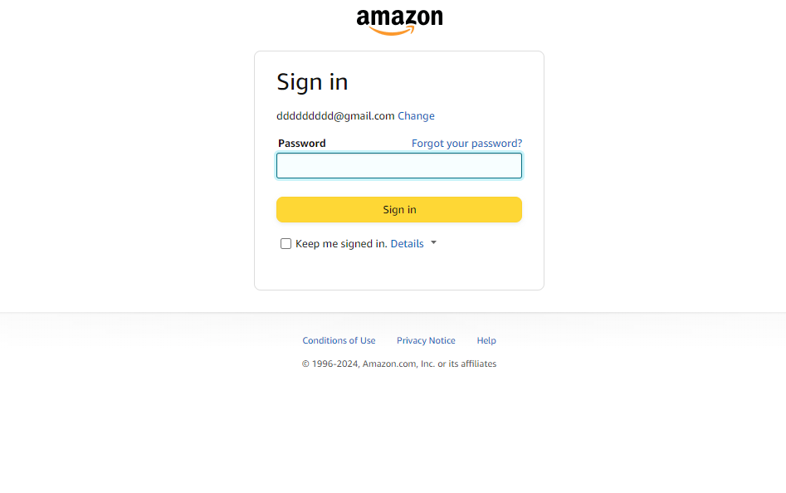

**Environment:**

* Operating system: Windows 10
* Browser: Chrome , version:  Version 122.0.6261.96 (Official Build) (64-bit)

**Priority: high**

**Severity: major**

**BUG REPORT : 3**

**Date**: 03-07-2024

**Reported by**: Mirza MD Tawhid

**Summary:** Create Account Username Issue

**Descripton:**

When we give input on username field ,it takes only number such as 12131242. That should not be valid.

**Steps to reproduce**:

* Go to application
* Go to Create Account
* input : username field = “anynumber”
* The validation option shows valid

**Expected Result:**

* system should display an error messege

**Actual Result**: It shows valid

**Attachments:**

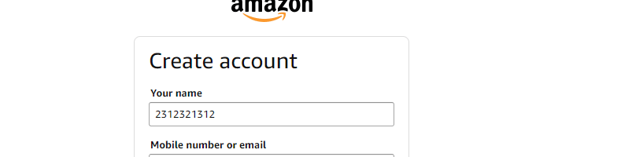

**Environment:**

* Operating system: Windows 10
* Browser: Chrome , version:  Version 122.0.6261.96 (Official Build) (64-bit)

**Priority: moderate**

**Severity: moderate**